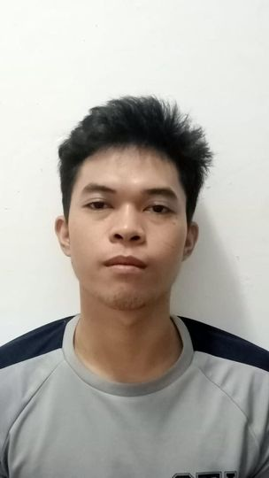

**MARC LAURENCE NIBUNGCO**

131# Sto. Niño, Concepcion, Malabon City

09187527061

*Amorenibungco27@gmail.com*

**Objective :**

To obtain a position that will enable me to use my strong organizational skills, educational background and ability to work well with the people.

**Work Experience :**

* **Masagana Agency ( OROCAN PLASTIC )**

*Delivery Helper*

(January 10, 2021 – June 10, 2021)

* **Jollibee 10th Ave.**

Service Crew – Kitchen

(July 15, 2019 – November 10, 2019)

**Skills :**

* Computer Literate
* Team Leader (Handling, Decision Making, Motivating)
* Good Communication
* High Initiative
* Perseverance

**Educational Background :**

* **STI Caloocan**

*BSHM- Bachelor of Science – Hotel Management*

2019 – Undergrad (1st Year. 2nd Sem.)

* **Arellano University**

Senior High

(2017 – 2019)

* **Malabon National High School**

Junior High

(2012 - 2017)

* **Amang Rodriguez Elementary School**

*Primary*

(2006 -2012)

**Personal Information :**

Birthdate: June 25, 2000

Age: 22 yrs. Old

Religion: Roman Catholic

Height: 5'6

Weight: 55kg.

Languange: Tagalog and English

**Character Reference:**

**Queenie Delos Santos**

Ospital ng Malabon

Nurse

09326183250

**Mark Peter Tagulao**

Ninjavan

Assistant Station Head

09293286129

**Jeffrey Dela Cruz**

Frabelle

Accounting Supervisor

09104124456

____________________________

The information above is based on facts and experience.